4CS015 – Portfolio Part -4

STUDENT NAME: Sagar Mishra
STUDENT NUMBER: 2606063

You will need to complete the workshop and then submit this Word file, complete with your answers, via Canvas, by the end of Semester (week 12).
For this assignment (workshop) you will show you how to navigate and create file systems from command prompt in both Windows (os) and Linux (os), also how to create a batch file to be executed in the Windows (os).

NOTE: Please make sure you have written your command as well as the screenshot of the commands. Failure to do so will result in marks deduction.

Table of Contents
4CS015 – Portfolio Part -4 1
Task 1 (Windows Command Line) 2
Task 2 3
Task 3 (Linux terminal) 2
Task 4 3
Task 5 5

Task 1 (Windows Command Line)

- Write a command to Create a directory "test"
Ans: mkdir test
- Write the command to list all the directories/files inside the directory test
Ans: dir test
- Create a file "hello.txt" containing the word "Hello", inside the test directory.
Ans: echo Hello > test\hello.txt
- Display the content of hello.txt in the command line.
Ans: type test\hello.txt
- Make directory test1 in the Desktop and copy hello.txt from test to test1
Ans: mkdir %USERPROFILE%\Desktop\test1
copy test\hello.txt %USERPROFILE%\Desktop\test1\
- Now delete the file hello.txt in the current directory
Ans: del hello.txt
- Write a command to display your current directory.
Ans: cd
- Now rename the file to hello2.txt
Ans: rename hello.txt hello2.txt
- Now navigate outside the directory test.
Ans: cd ..
- Write the command to print the tree structure. It should look something like this:
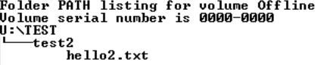

Ans: tree /f

Task 2
Create the following directory structure and paste it after this picture. (15 marks):
Note: MYMODULES must be inside <your_name> directory.
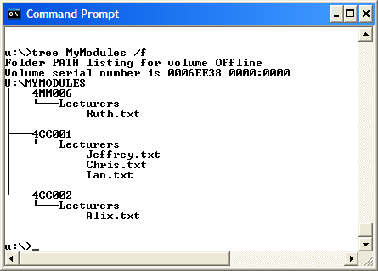
Make a directory with your name on the desktop and navigate to the directory before you display the following structure.

cd %USERPROFILE%\Desktop
mkdir YourName
cd YourName
mkdir MYMODULES
cd MYMODULES
mkdir 4MM006
mkdir 4CC001
mkdir 4CC002
mkdir 4MM006\Lecturers
mkdir 4CC001\Lecturers
mkdir 4CC002\Lecturers
type nul > 4MM006\Lecturers\Ruth.txt
type nul > 4CC001\Lecturers\Jeffrey.txt
type nul > 4CC001\Lecturers\Chris.txt
type nul > 4CC001\Lecturers\Ian.txt
type nul > 4CC002\Lecturers\Alix.txt
tree MYMODULES /f
(dir /s /b)
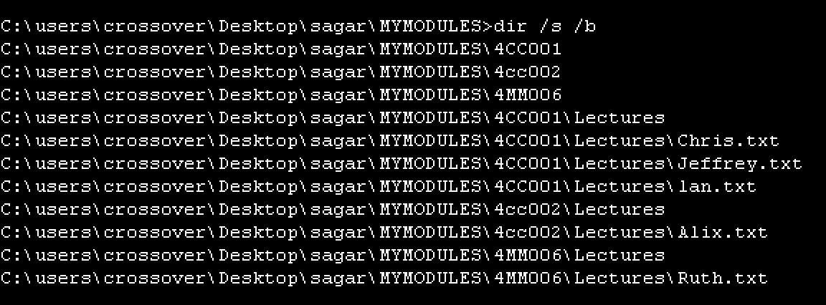
Task 3 (Linux terminal) (10 marks)
Now, Boot into Linux operating system in virtualbox or Windows-SubSystem for LInux(On Windows)
- Write a command to Create a directory "test"
Ans: mkdir test
- Write the command to list all the directories/files inside the directory test
Ans: ls test
- Create a file "hello.txt" containing the word "Hello", inside the test directory.
Ans: echo “Hello” > test/hello.txt
- Display the content of hello.txt in the command line.
Ans: cat test/hello.txt
- Make directory test1 in the Desktop and copy hello.txt from test to test1
Ans: mkdir ~/Desktop/test1
cp test/hello.txt ~/Desktop/test1/
- Now delete the file hello.txt in the current directory
Ans: rm test/hello.txt
- Write a command to display your current directory.
Ans: pwd
- Now rename the file to hello2.txt
Ans: mv hello.txt hello2.txt
- Now navigate outside the directory test.
Ans: cd . .
- Write the command to print the tree structure.
Ans: tree

Task 4
Create the following directory structure (identical to the one that you created in Windows Command Prompt):
Note: MYMODULES must be inside <your_name> directory.
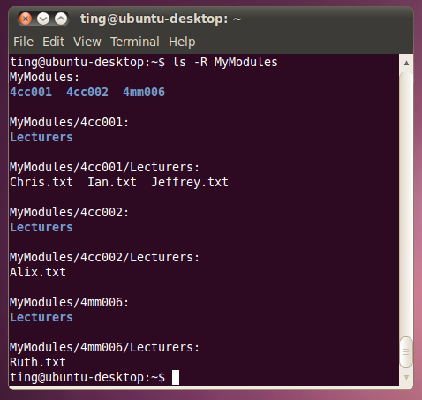
and insert it below (15 marks):
[Insert your picture here]

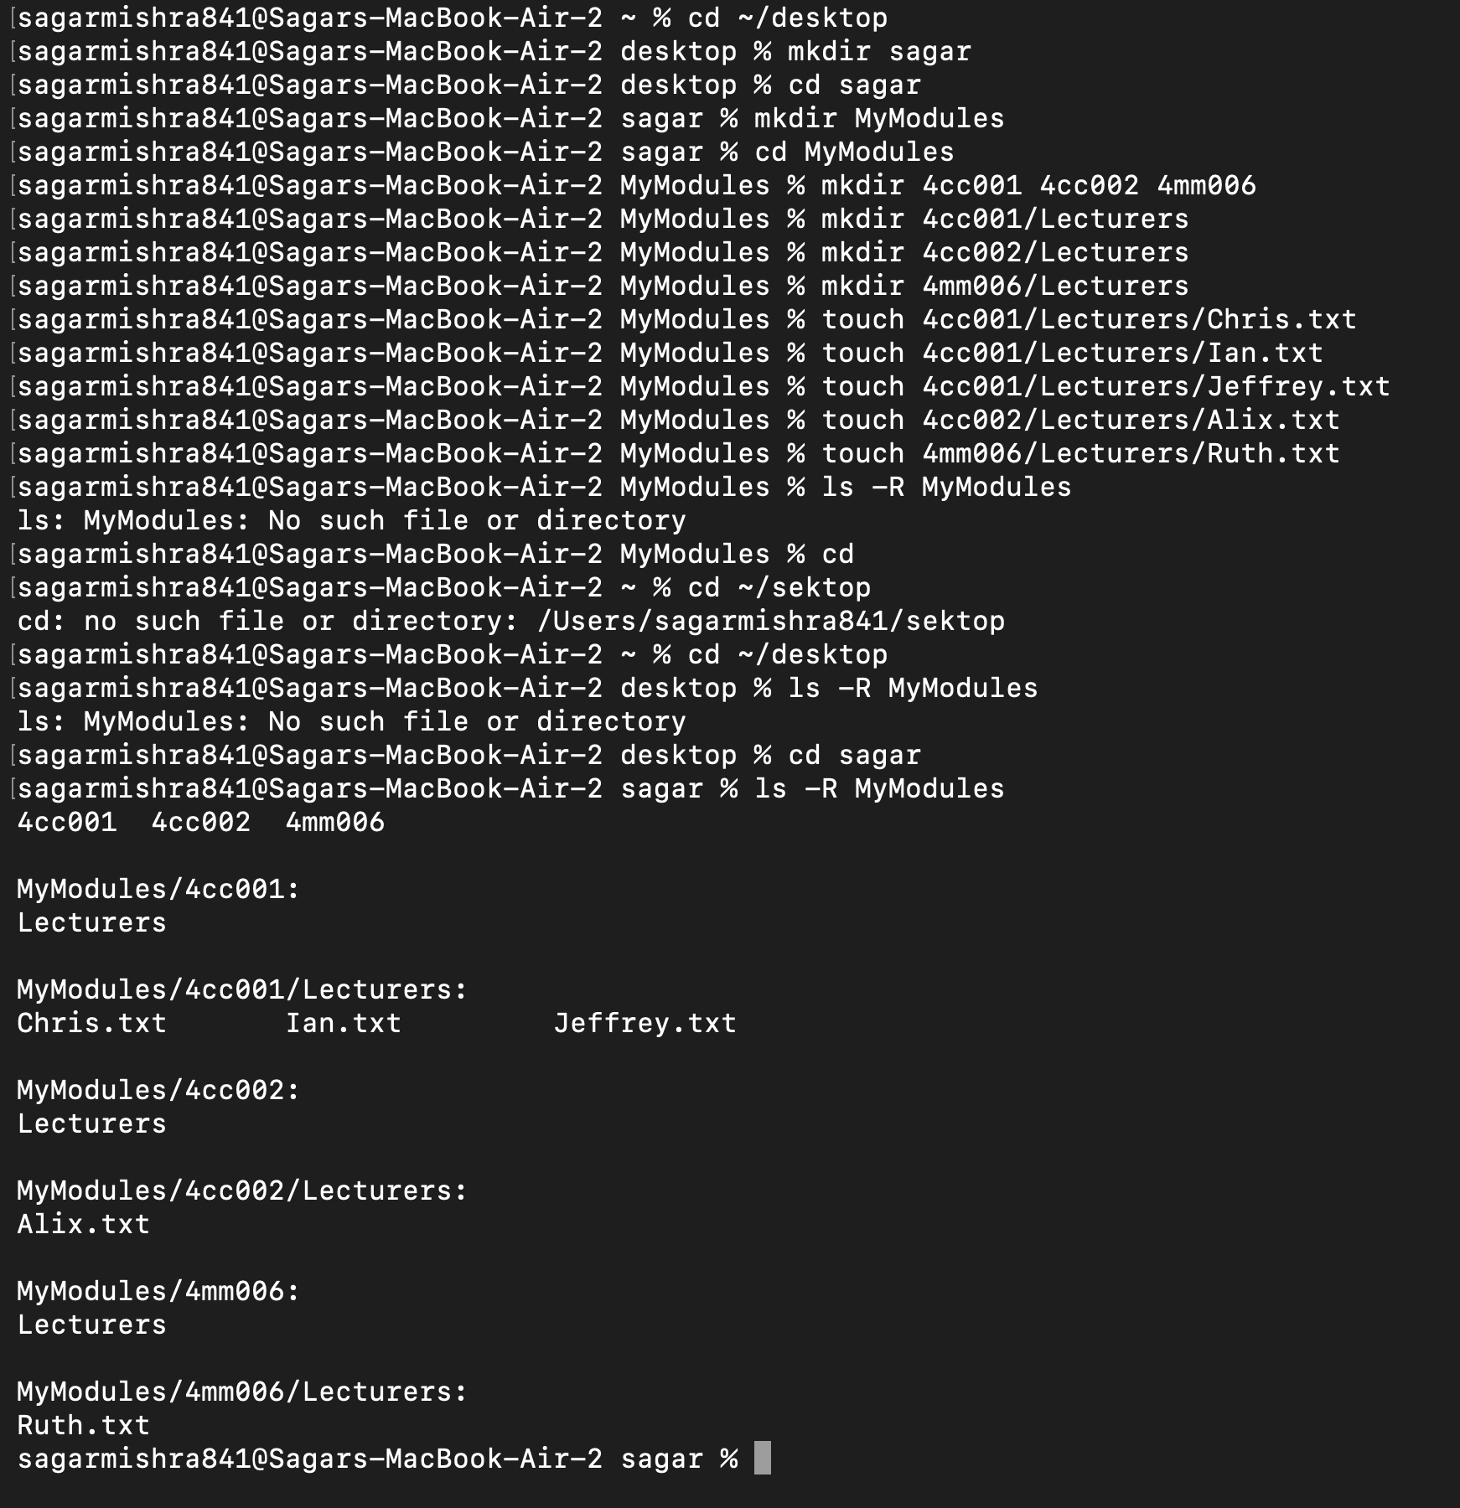

Task 5
Batch file material (50 marks in total)
Create a batch file (windows) YourNumber.bat from notepad (or your preferred text editor).
The batch file should create a directory structure similar to the one create for the first section of this assignment but the directory entries should be provided from an input request from the batch file itself.
You should be able to create a root directory and directory structure and populate it if required. The batch file program will ask for names (input directory names and file names) to be used and have some form of error checking (empty – incorrect character, length, etc.) You can add other features such as being able to edit the new structure from within the batch file program (find and change a directory name).
Run batch file from windows prompt: YourNumber.bat <enter>

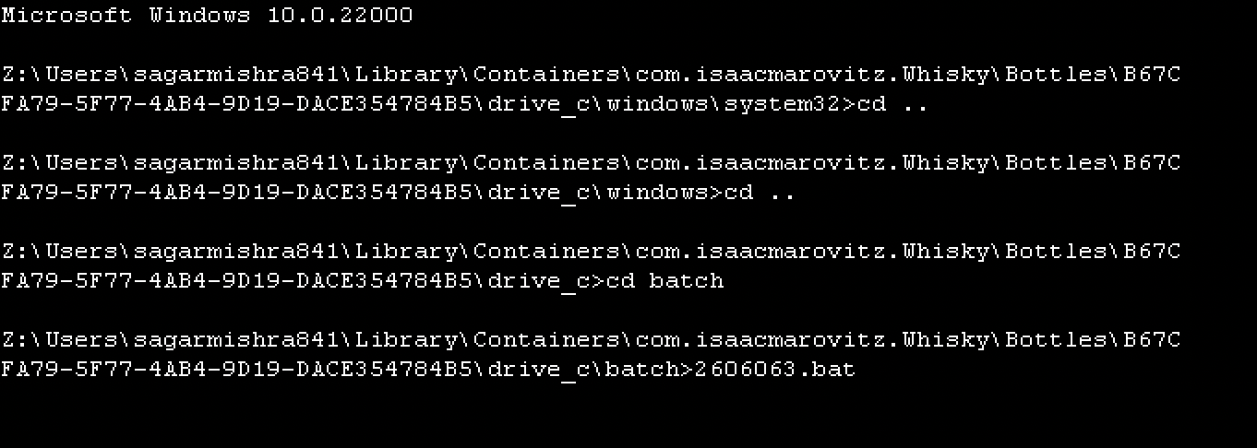
[Insert your picture(s) here] – Directory structure created / menu of batch file (inputs and output when batch file is executed) (10 marks)

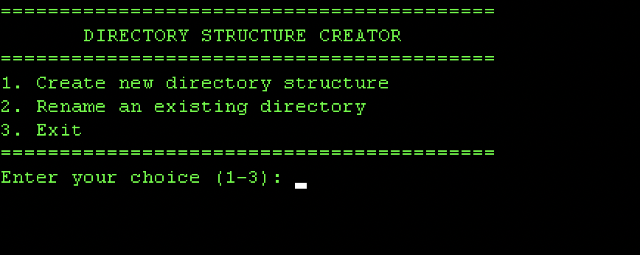

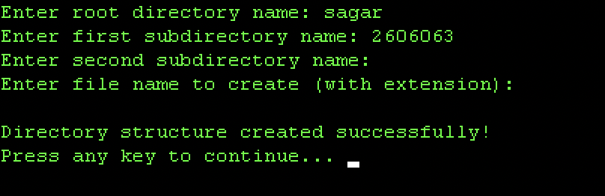

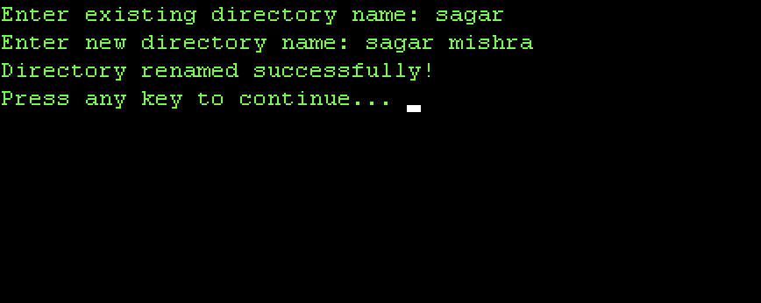

[Insert your text here] – Batch file listing (script)(40 marks)

@echo off
title Dynamic Directory Structure Creator
color 0A
:MENU
cls
echo ==========================================
echo DIRECTORY STRUCTURE CREATOR
echo ==========================================
echo 1. Create new directory structure
echo 2. Rename an existing directory
echo 3. Exit
echo ==========================================
set /p choice=Enter your choice (1-3):
if "%choice%"=="1" goto CREATE
if "%choice%"=="2" goto RENAME
if "%choice%"=="3" exit
echo Invalid choice!
pause
goto MENU
:CREATE
cls
set /p ROOT=Enter root directory name:
:: Error checking for empty input
if "%ROOT%"=="" (
echo Root directory name cannot be empty!
pause
goto CREATE
)
mkdir "%ROOT%" 2>nul
if errorlevel 1 (
echo Directory already exists or invalid name!
pause
goto MENU
)
cd "%ROOT%"
set /p D1=Enter first subdirectory name:
if "%D1%"=="" goto SKIP1
mkdir "%D1%"
:SKIP1
set /p D2=Enter second subdirectory name:
if "%D2%"=="" goto SKIP2
mkdir "%D2%"
:SKIP2
set /p FILE1=Enter file name to create (with extension):
if "%FILE1%"=="" goto DONE
echo This is a sample file > "%FILE1%"
:DONE
echo.
echo Directory structure created successfully!
cd ..
pause
goto MENU
:RENAME
cls
set /p OLD=Enter existing directory name:
if not exist "%OLD%" (
echo Directory does not exist!
pause
goto MENU
)

set /p NEW=Enter new directory name:
if "%NEW%"=="" (
echo New name cannot be empty!
pause
goto MENU
)

ren "%OLD%" "%NEW%"
echo Directory renamed successfully!
pause
goto MENU

